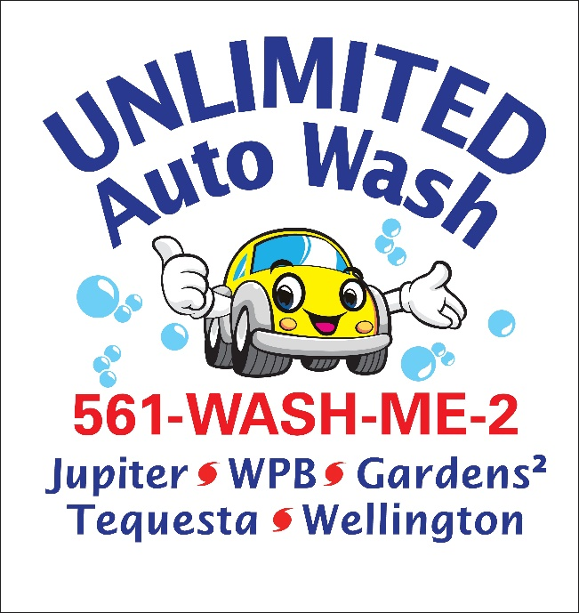

Unlimited Auto Wash of Jupiter has become an Environmentally Certified Sustainable Business
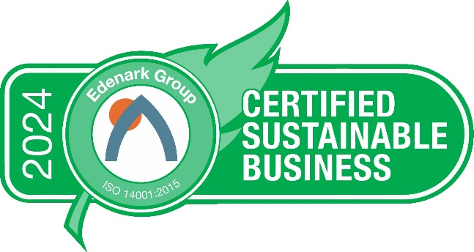

Unlimited Auto Wash of Jupiter, FL, is part of the seven-location Unlimited Auto Wash Club (https://www.unlimitedautowashclub.com/ ) that serves South Florida. Unlimited Auto Wash is a 100% Full Service Hand Car Wash with over 170 employees. It cares deeply about the environment and the community it serves, and has pursued and attained the Edenark Group ISO 14001 environmental sustainability certification for 2024.
The Edenark Group ISO 14001 is the world’s premier environmental sustainability certification program and allows SMEs (small to mid-sized enterprises) the ability to attain the world’s most popular environmental certification standard via a program designed and priced specifically for them. This allows an organization to validate, via 3rd party audit against the world’s top standard, its environmental / sustainability / green / eco-friendly actions.
The program, which allows companies to progressively improve at a pace that works for their needs, helps the organization define how it interacts internally, externally, and with the environment. It incorporates energy/waste/water, employee health and performance enhancement, community involvement, procurement and suppliers, compliance and regulations, emergency/security, and stakeholder engagement. Benefits include creating a culture of continual improvement, stakeholder engagement, lower costs, higher revenues and profits, improved employee performance, and...... doing the right thing for the environment for current and future generations.

“Greenwashing is rampant in the car wash industry. Many organizations, looking to cash in on consumer demand, claim to be environmentally friendly, but most practice greenwashing by self-auditing or self-certifying or using non-globally-recognized programs. We wanted to be the first certified sustainable car wash in the region as we are a leader in our industry,” says Kevin Dalton, CEO of Unlimited Auto Wash. “We decided we were going to pursue environmental sustainability the way we run our business - the right way. The Edenark Group ISO 14001 sustainability certification program provides us that opportunity. This will be wonderful for all our stakeholders; our customers, our employees, our company and our community.”
"When an organization pursues, and attains, the Edenark Group ISO 14001 sustainability certification, they are not just doing it to see their costs go down and revenues and profits go up. They are setting a higher bar for their organization and sending a message to all those around them that may be claiming to be environmentally-supportive, but are in truth greenwashing by not validating their actions under a global 3rd party certification," says David Goodman, CEO of Edenark Group. "Companies who are agreeing to adhere to the world’s Gold standard for sustainability certification are allowing their actions to be reviewed; are choosing to be a leader and part of the solution, not the problem; and are joining an elite fraternity of over 400,000 organizations, in over 150 countries, that have committed to continually improving in every way."
Unlimited Auto Wash (https://www.unlimitedautowashclub.com/ ) can be reached at +1 561-WASH-ME-2
Edenark Group (https://edenark.com ) can be reached at +1 561.512.2257

