

DataSetGo has renewed its Environmental Sustainability Certification through 2025
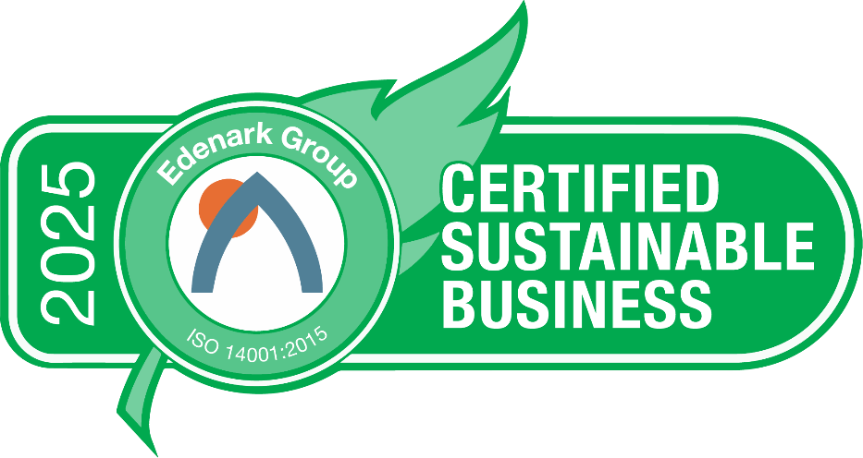

DataSetGo ( https://datasetgo.llc/ ), a Marco Island, Florida software company that creates customized solutions with enterprise-level features yet designed and priced to serve and scale with entry-level businesses, has renewed its Edenark Group ISO 14001 environmental sustainability certification though 2025.
The Edenark Group ISO 14001 is the world’s premier environmental sustainability certification program and allows SMEs (small to mid-sized enterprises) the ability to attain the world’s most popular environmental certification standard via a program designed and priced specifically for them.
The program, which allows companies to progressively improve at a pace that works for their needs, helps the organization define how it interacts internally, externally, and with the environment. It incorporates energy/waste/water, employee health and performance enhancement, community involvement, procurement and suppliers, compliance and regulations, emergency/security, and stakeholder engagement. Benefits include creating a culture of continual improvement, stakeholder engagement, lower costs, higher revenues and profits, improved employee performance, and...... doing the right thing for the environment and current and future generations.
“Serving people and protecting our community is at the core of the DataSetGo culture. We choose to walk the talk and be part of the solution,” said James C Murray, CEO of DataSetGo. “Our software model allows our product to scale and grow as our client grows. We like the fact that the Edenark Group ISO 14001 program follows the same philosophy of progressive improvement, allowing us to continue to grow and improve in our sustainability effort,” added Murray.
“Given that we are part of a supply chain, with Wholesales Payroll and OnlinePayroll Services, we want to use 2025 as an advocacy year, helping other supply chains to become certified sustainable. Scope 3 mandates and government regulations are no longer things in the future; as global warming is no longer something in the future. We choose to be part of the solution and hope to help others do likewise,” said Al Wagner, Chief Revenue Officer of DataSetGo.

"When an organization pursues, and attains, the Edenark Group ISO 14001 sustainability certification, they are not just doing it to see their costs go down and revenues and profits go up. They are setting a higher bar for their organization and sending a signal to all those around them," says David Goodman, CEO of Edenark Group. "They are agreeing to adhere to the world’s Gold standard for sustainability certification; are choosing to be a leader and part of the solution, not the problem; and are joining an elite fraternity of over 300,000 organizations, in over 150 countries, that have committed to continually improving in every way."
DataSetGo (https://datasetgo.llc/ ) can be reached at +1.239.427-4224
Edenark Group (https://edenark.com ) can be reached at +1 561.512.2257

