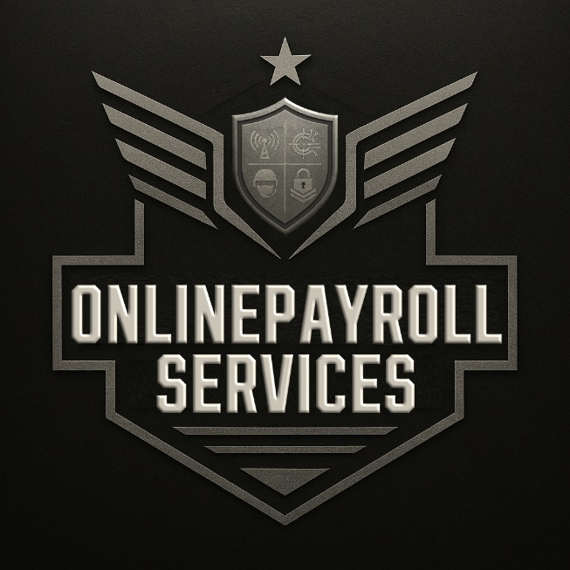

OnlinePayroll Services has renewed its Environmental Sustainability Certification through 2025

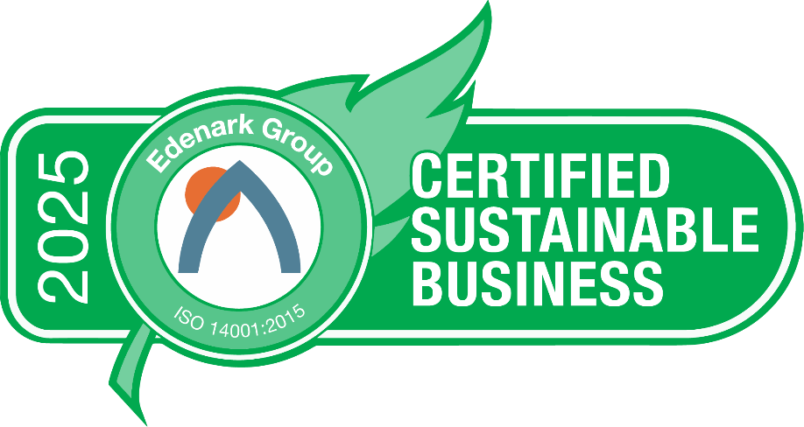

OnlinePayroll Services ( https://onlinepayroll.services/ ), previously known as TruPayroll (https://www.trupayroll.com/ ), a relationship-driven, full service, payroll provider, located in Marco Island, Florida has continued its environmental sustainability commitment by renewing and extending its Edenark Group ISO 14001 sustainability certification through 2025.
The Edenark Group ISO 14001 is the world’s premier environmental sustainability certification program and allows SMEs (small to mid-sized enterprises) the ability to attain the world’s most popular environmental certification standard via a program designed and priced specifically for them. Edenark Group also helps clients pursue carbon neutrality and ESG compliance, using the Edenark Group ISO 14001 as a foundation for long term compliance.
The program, which allows companies to progressively improve at a pace that works for their needs, helps the organization define how it interacts internally, externally, and with the environment. It incorporates energy/waste/water, employee health and performance enhancement, community involvement, procurement and suppliers, compliance and regulations, emergency/security, and stakeholder engagement. Benefits include creating a culture of continual improvement, stakeholder engagement, lower costs, higher revenues and profits, improved employee performance, and...... doing the right thing for the environment and current and future generations.
“I love helping people beyond my core corporate service. We strive to have a positive impact on our clients’ personal lives, their businesses, and their community,” said Al Wagner, CEO of OnlinePayroll Services. “This desire to help others is what caused me to become passionate about sustainability. I want to be part of the global solution by making an impact in my community, for my family and my clients’ families. The Edenark Group ISO 14001 program gives me that platform,” added Wagner.
“Further, OnlinePayroll Services l is part of a supply chain that includes WholeSale Payroll and DataSetGo. All three companies are environmentally certified sustainable,” added Wagner.
“Edenark Group has a wonderful multi-year relationship with OnlinePayroll Services and its predecessor, TruPayroll. They are an example of what the world needs more of – an organization that produces a superior product, supports its current stakeholders, shows it cares about future generations via its commitment to sustainability certification, and makes more money due to its sustainability programs,” said David Goodman, CEO of Edenark Group. “When an organization executes the Edenark Group ISO 14001 sustainability certification, as OnlinePayroll Services is doing, it not only benefits the environment, but it also benefits its own operation and its clients,” added Goodman.
OnlinePayroll Services ( https://onlinepayroll.services/ ), previously known as TruPayroll (https://www.trupayroll.com/ ) can be reached at +1.239.394.0358
Edenark Group (https://edenark.com ) can be reached at +1 561.512.2257

